

Installation Guide
OpenL Tablets BRMS
Release 5.17

Document number: TP_OpenL_IG_2.2_LSh
Revised: 04-28-2016
OpenL Tablets Documentation is licensed under a Creative Commons Attribution 3.0 United States License.

Table of Contents
1 Preface 5
1.1 How This Guide Is Organized 5
1.2 Audience 5
1.3 Related Information 6
1.4 Typographic Conventions 6
2 Before You Begin 7
3 Install OpenL Tablets WebStudio under Apache Tomcat 8
3.1 Installing JDK 8
3.2 Installing Apache Tomcat 9
Installing Apache Tomcat on Windows 9
Installing Apache Tomcat on UNIX / Linux Machine 11
3.3 Deploying OpenL Tablets WebStudio 12
Deploying OpenL Tablets WebStudio on a Windows Machine 13
Deploying OpenL Tablets WebStudio on a Linux Machine 13
3.4 Configuring External User Database 14
Configuring MySQL Database as External User Storage 14
Configuring Oracle Database as External User Storage 15
3.5 Setting Up OpenL Tablets WebStudio with Installation Wizard 17
Configuring OpenL Tablets WebStudio via JDBC Connection 18
Configuring OpenL Tablets WebStudio via JNDI Connection 19
3.6 Configuring Settings for Microsoft Excel Application 21
3.7 OpenL Tablets WebStudio Customization 22
Updating User Database Configuration 22
Configuring User Mode 23
Configuring Google Analytics 23
Configuring Private Key for Repository Security 23
4 Deploy OpenL Tablets Web Services under Apache Tomcat 24
4.1 Downloading Preconfigured OpenL Tablets Web Services 24
4.2 Configuring OpenL Tablets Web Services for a Local File System Data Source 24
4.3 Configuring File System Data Source to Support Versioning of Deployments 25
4.4 Configuring OpenL Tablets Web Services for a Database Data Source 26
Adding Drivers and Installing and Configuring the Database 26
Configuring OpenL Tablets Web Services via JDBC Connection 27
Configuring OpenL Tablets Web Services via JNDI Connection 27
5 Install OpenL Tablets WebStudio and OpenL Tablets Web Services on WebSphere Application Server 29
5.1 Prerequisites 29
5.2 Setting Up JVM Options for WebSphere Application Server 29
5.3 Preparing OpenL Tablets WAR Files 30
5.4 Deploying OpenL Tablets Web Applications on WebSphere Application Server 30
Deploying OpenL Tablets WebStudio on WebSphere Application Server 30
Deploying OpenL Tablets Web Services on WebSphere Application Server 31
5.5 Configuring Settings for JDBC Connection 31
5.6 Configuring Settings for JNDI Connection 31
Configuring Global JNDI Context 31
Configuring Local JNDI Context 35
5.7 Configuring Settings for Microsoft Excel Application 35
6 OpenL Tablets WebStudio and Web Services Integration 36
6.1 Deploying Rules to the Production Server 36
6.2 Integrating OpenL Tablets WebStudio and OpenL Tablets Web Services via Jackrabbit Repository 37
6.3 Integrating OpenL Tablets WebStudio and OpenL Tablets Web Services via Database Repository 38
6.4 Enabling Backward Compatibility of OpenL Tablets WebStudio with Previous Versions of OpenL Tablets Web Services 38
7 Troubleshooting Notes 39
8 Frequently Asked Questions 40

Preface
OpenL Tablets is a Business Rules Management System (BRMS) based on tables presented in Excel documents. Using unique concepts, OpenL Tablets facilitates treating business documents containing business logic specifications as an executable source code.
OpenL Tablets provides a set of tools addressing BRMS related capabilities including OpenL Tablets WebStudio that can be used for creating, testing, and managing business rules and business rule projects, and OpenL Tablets Web Services designed for integration of business rules into customer applications.
The OpenL Tablets Installation Guide provides instructions for installing and customizing OpenL Tablets software. The document describes how to install OpenL Tablets under Apache Tomcat, deploy, and set up OpenL Tablets Web Services.
This section includes the following topics:
- How This Guide Is Organized
- Audience
- Related Information
- Typographic Conventions

How This Guide Is Organized
Information on how to use this guide
Section | Description
Before You Begin | Lists system requirements for installing and using OpenL Tablets software.
Install OpenL Tablets WebStudio under Apache Tomcat | Explains how to install OpenL Tablets WebStudio under Apache Tomcat.
Deploy OpenL Tablets Web Services under Apache Tomcat | Designed for rule developers who need to use business rules as separate web services.
Install OpenL Tablets WebStudio and OpenL Tablets Web Services on WebSphere Application Server | Explains how to install OpenL Tablets WebStudio and OpenL Tablets Web Services on WebSphere Application Server.
OpenL Tablets WebStudio and OpenL Tablets Web Services Integration | Explains how to set up OpenL Tablets WebStudio and OpenL Tablets Web Services as an integrated environment.
- Troubleshooting Notes  - Frequently Asked Questions | Provides useful information related to OpenL Tablets installation.

Audience
This guide is mainly targeted at business users and rule experts who define, view, and manage their business rules and rule projects via OpenL Tablets WebStudio. Developers can also use this document to learn how to install and set up OpenL Tablets Web Services.
Basic knowledge of Java and Apache Tomcat is required to use this guide effectively.

Related Information
The following table lists sources of information related to contents of this guide:
Related information
Title | Description
[OpenL Tablets WebStudio User Guide] | Describes OpenL Tablets WebStudio, a web application for managing OpenL Tablets projects through web browser.
[OpenL Tablets Reference Guide] | Provides overview of OpenL Tablets technology, as well as its basic concepts and principles.
http://openl-tablets.org/ | OpenL Tablets open source project website.

Typographic Conventions
The following styles and conventions are used in this guide:
Typographic styles and conventions
Convention | Description
Bold | - Represents user interface items such as check boxes, command buttons, dialog boxes, drop-down list values, field names, menu commands, menus, option buttons, perspectives, tabs, tooltip labels, tree elements, views, and windows.  - Represents keys, such as F9 or CTRL+A.  - Represents a term the first time it is defined.
Courier | Represents file and directory names, code, system messages, and command-line commands.
Courier Bold | Represents emphasized text in code.
Select File > Save As | Represents a command to perform, such as opening the File menu and selecting Save As.
Italic | - Represents any information to be entered in a field.  - Represents documentation titles.
< > | Represents placeholder values to be substituted with user specific values.
Hyperlink | Represents a hyperlink. Clicking a hyperlink displays the information topic or external source.
[name of guide] | Reference to another guide that contains additional information on a specific feature.

Before You Begin
The following table covers system requirements for installing and running OpenL Tablets software:
Software requirements
Software | Requirements description
Operating systems | One of the following:  - Microsoft Windows 7 x86/64  - Ubuntu 12.x  - Linux 3.x  Note: OpenL Tablets software can potentially run on any operating system that supports Java Virtual Machine, e.g. Mac OS. This table lists operating systems on which the OpenL Tablets software is tested and supported.
Browsers | One of the following:  - Microsoft Internet Explorer 9/10/11.x  - Firefox 44.x or later  - Chrome 48.x or later
Other software | - Java v6/7/8 x86/64  - Apache Tomcat 7.x.x, 8.0.x
Hardware requirements
- RAM 4 GB minimum.
6 GB is recommended.
- 1 GHz or faster 32-bit (x86) or 64-bit (x64) processor.
User rights requirements
 | Administrative permissions are required to install the software under Microsoft Windows or UNIX system.
Note: It is highly recommended to avoid using spaces and special characters in paths.

Install OpenL Tablets WebStudio under Apache Tomcat
This section describes how to set up the environment for working with OpenL Tablets software and deploy OpenL Tablets WebStudio under Apache Tomcat, and provides information about settings required for proper functioning of the application.
Perform the following steps:
- Installing JDK
- Installing Apache Tomcat
- Deploying OpenL Tablets WebStudio
- Configuring External User Database
- Setting Up OpenL Tablets WebStudio with Installation Wizard
- Configuring Settings for Microsoft Excel Application
- OpenL Tablets WebStudio Customization

Installing JDK
To install JDK, perform the following steps:
- Download JDK 1.7.0_x or later from http://www.oracle.com/technetwork/java/javase/downloads/index.html to the target directory.
Further in the document, this catalog is referred to as <JAVA_HOME>.
Note: It is highly recommended to avoid installing Java in the default Program Files directory because it can cause problems due to space characters in the path to the folder.
For more information on the installation, see http://www.oracle.com/technetwork/java/javase/index-137561.html.
- Install JDK according to the instructions.
Now the environment variable JAVA_HOME must be set to the pathname of the directory where JDK is installed.
- For MS Windows, set the environment variable JAVA_HOME as follows:
- To open the System Properties window, press <Windows> + <Pause> or right click the My Computer icon and in the pop-up menu, select Properties.
- In the Advanced tab, click Environment Variables.
- In the System variables area, click New.
- In the Variable name field, enter JAVA_HOME.
- In the Variable value field, enter the path to the directory where JDK is installed, for example, C:\Java\jdk1.7.0_20.
- Click OK to complete.
- For Unix/Linux environments, assuming the target directory is /usr/lib/jvm/java-6-sun, to set up the environment variable JAVA_HOME for a single user, proceed as follows:
- Log in to the account and open .bash_profile:nano ~/.bash_profile.
- Add the following line:
export JAVA_HOME=/usr/lib/jvm/java-6-sun.
- Add or correct the system PATH as follows:
export PATH=$PATH:$JAVA_HOME/bin
- To save, press CTRL+O and then press CTRL+X to exit.
- For Unix/Linux environments, assuming the target directory is /usr/lib/jvm/java-6-sun, to set up the environment variable JAVA_HOME for all users, proceed as follows:
- Log in as root and open the nano /etc/profile profile.
- Add the following line:
export JAVA_HOME=/usr/lib/jvm/java-6-sun
- Add or correct the system PATH as follows:
export PATH=$PATH:$JAVA_HOME/bin

Installing Apache Tomcat
Apache Tomcat can be installed from a ZIP file or using Windows Service Installer. The following topics are included in this section:
- Installing Apache Tomcat on Windows
- Installing Apache Tomcat on UNIX / Linux Machine

Installing Apache Tomcat on Windows
This section describes how to install Apache Tomcat on Windows and includes the following topics:
- Installing Apache Tomcat from Zip File
- Installing Apache Tomcat Using Windows Service Installer

Installing Apache Tomcat from Zip File
To install Apache Tomcat 7.0.x or later, proceed as follows:
- Open Apache Tomcat home page at http://tomcat.apache.org/index.html.
- In the left-hand Download menu, click the latest available Tomcat version.
- Locate the Binary Distributions area and in the Core list, click on the ZIP file corresponding to the required Windows version.
- Save the ZIP file in a temporary directory.
- Extract the downloaded ZIP file into the target folder on the computer.
This folder is referred to as <TOMCAT_HOME> further in this document.
- Configure JVM options for Tomcat web server as follows:
- Create TOMCAT_HOME/bin/setenv.bat file and add the following line:
set JAVA_OPTS=%JAVA_OPTS% -Xms512m -Xmx2000m -XX:+ +UseParNewGC -XX:PermSize=128m -XX:MaxPermSize=512m
- Open the TOMCAT_HOME/conf/server.xml file and add the URIEncoding="UTF-8" attribute for all <Connector> elements.
For example:
<Connector port="8080" protocol="HTTP/1.1" connectionTimeout="20000" redirectPort="8443" URIEncoding="UTF-8"/>

Installing Apache Tomcat Using Windows Service Installer
This section describes how to install Apache Tomcat using Windows Service Installer.
Note: It is not recommended to select this type of installation if planning to edit rule tables in Excel files from OpenL Tablets WebStudio as described in [OpenL Tablets WebStudio User Guide], the Modifying Tables section. This type of installation requires additional setup. To solve this issue, contact your OpenL Tablets administrator.
Note: For OpenL Tablets administrator: to enable editing rule tables in Excel files from OpenL Tablets WebStudio, enable the Allow service to interact with desktop Tomcat service option using MMC or from the command line.
Proceed as follows:
- Navigate to the Apache Tomcat site at http://tomcat.apache.org/index.html and in the left-hand Download menu, click the latest available Tomcat version.
- Locate the Binary Distributions area and in the Core list, click the 32-bit/64-bit Windows Service Installer link.
Save the apache-tomcat exe file in a temporary folder.
- Run the exe file and follow the instructions of the installation wizard.
- Click Next.
- In the License Agreement window, click I Agree.
- In the Choose Components dialog, leave the default Normal type of installation.
Experienced Tomcat users can select another installation type in the drop-down list.
- In the Configuration dialog, proceed with default values.
- In the next window, review the folder where Tomcat will be installed, the Destination Folder.
This folder is referred to as <TOMCAT_HOME> further in this document.
- Click Install to start the installation.
- Click Finish to complete.
As a result, Apache Tomcat is installed and started on the user’s computer. In the Notification Area located next to the clock, the icon appears. Tomcat is managed by using this icon or from the Start menu.
- To configure JVM options for Tomcat, in the Notification area, right click the Apache Tomcat icon and select Configure; or click Start > All Programs > Apache Tomcat 7.0 > Configure Tomcat.
The Apache Tomcat Properties dialog appears.
- Click the Java tab and in the Java Options text box, add the following lines:
-Xms512m
-Xmx2000m
-XX: +UseConcMarkSweepGC
-XX:PermSize=128m
-XX:MaxPermSize=512m
Note that every option must be manually entered in a separate row.
- Click Apply and then click OK.
- To restart Tomcat, in Notification Area, right click the Tomcat icon and select Stop service.
The Tomcat icon changes to .
- Select Start Service.
Alternatively, Tomcat can be restarted from the General tab in the Apache Tomcat Properties window which appears after selecting Start > All Programs > Apache Tomcat 7.0 > Configure Tomcat.
From this point, OpenL Tablets WebStudio can be run as described in Deploying OpenL Tablets WebStudio.

Installing Apache Tomcat on UNIX / Linux Machine
This section describes how to install Apache Tomcat on the UNIX or Linux machine and includes the following topics:
- Installing Apache Tomcat from Repository
- Installing Apache Tomcat from ZIP File
- Configuring JVM Options for Tomcat on UNIX / Linux Machine

Installing Apache Tomcat from Repository
This section describes how to install Apache Tomcat from repository as a service on Ubuntu 12.x.
Note: All commands must be entered into a terminal window using an account with sudo privileges.
Proceed as follows:
- Open a terminal window and enter the following:
sudo apt-get install tomcat7
- Start Tomcat with the next command:
sudo /etc/init.d/tomcat7 start
All necessary folders must be located in /var/lib/tomcat7.
- To ensure that Tomcat works properly, open the browser and enter http://localhost:8080.
If all is correct, Apache Tomcat displays the welcome page with a message similar to the following:
If you're seeing this, you've successfully installed Tomcat. Congratulations!
- If the 404 error appears, try to restart Tomcat as follows:
sudo /etc/init.d/tomcat7 restart
- Alternatively, stop Tomcat by entering the following command and then start it as described previously:
sudo /etc/init.d/tomcat7 stop

Installing Apache Tomcat from ZIP File
This section describes how to install Apache Tomcat on Ubuntu 12.04 and Centos 6.3. The instructions are valid for other Linux distributions with small changes.
Proceed as follows:
- Download the appropriate Tomcat archive file, ZIP or tar.gz archive, from its official website http://tomcat.apache.org/download-70.cgi to the required user folder.
In this example, Tomcat 7.0.39 is downloaded to the /home/myuser folder.
- Open a terminal window and change directory to the folder containing the Tomcat archive.
- Extract the archive by entering the following command in the terminal, modifying the Tomcat version as required:
tar -zxvf apache-tomcat-7.0.39.tar.gz
The apache-tomcat-7.0.39 folder appears. For example:
/home/myuser/apache-tomcat-7.0.39
- Change directory to the tomcat/bin:
cd apache-tomcat-7.0.39/bin
- Make sure all *.sh files are executable, that is, they have r in all positions to the left of the file name, for example, -rwxr-xr-x.
For that, in terminal, enter the following:
ls –la
The following information is displayed:
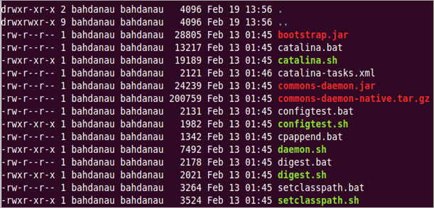
Figure 1: OpenL Tablets package is added
- If some sh files are not executable, enter the following command:
chmod +x ./*.sh
- Run the sturtup.sh file as follows:
sh ./startup.sh
- In the browser, enter the following URL:
http://localhost:8080
If the installation is completed successfully, the Apache Tomcat welcome screen appears. The next thing to be done is to configure JVM options for Tomcat.

Configuring JVM Options for Tomcat on UNIX / Linux Machine
To configure JVM options for Tomcat on a UNIX / Linux machine, proceed as follows:
- For UNIX, create TOMCAT_HOME/bin/setenv.sh file and type the following:
export JAVA_OPTS="$JAVA_OPTS -Xms512m -Xmx2000m -XX:+ UseConcMarkSweepGC -XX:PermSize=128m -XX:MaxPermSize=512m"
- Locate the TOMCAT_HOME/conf/server.xml file and add the URIEncoding="UTF-8" attribute for all <Connector> elements.
For example:
<Connector port="8080" protocol="HTTP/1.1" connectionTimeout="20000" redirectPort="8443" URIEncoding="UTF-8"/>
- From this point, deploy OpenL Tablets WebStudio as described in Deploying OpenL Tablets WebStudio.

Deploying OpenL Tablets WebStudio
This section describes how to deploy and run OpenL Tablets WebStudio under Tomcat.
The following topics are included:
- Deploying OpenL Tablets WebStudio on a Windows Machine
- Deploying OpenL Tablets WebStudio on a Linux Machine

Deploying OpenL Tablets WebStudio on a Windows Machine
This section describes how to deploy and run OpenL Tablets WebStudio under Tomcat on a Windows machine.
Proceed as follows:
- Go to the http://openl-tablets.org/downloads page.
- Click the appropriate OpenL Tablets WebStudio WAR link.
- Save the file in a temporary folder and then copy the OpenL Tablets WebStudio WAR file.
For example, openl-tablets-webstudio-X.X.X.war to the <TOMCAT_HOME>\webapps folder.
- Run Tomcat as follows:
- If Tomcat is installed from the ZIP file, in TOMCAT_HOME\bin, click the startup.bat file.
- If Tomcat is installed using Windows Service Installer, restart Tomcat as described in Installing Apache Tomcat Using Windows Service Installer.
Tomcat unpacks the WAR file into the <TOMCAT_HOME>\webapps\<war file name> folder. For example, for 5.9.4 version the target folder can be <TOMCAT_HOME>\webapps\openl-tablets-webstudio-5.9.4. For convenience, the folder can be renamed as needed but remember that this name is used to launch OpenL Tablets WebStudio under Tomcat.
From this point on, run OpenL Tablets WebStudio with default settings or make additional customizations by changing the user mode and configuring an external user database as described in [OpenL Tablets Web Services Usage and Customization Guide].
- To run OpenL Tablets WebStudio, in the browser, enter the following URL:
http://localhost:8080/<WAR file name>
That is, for this example, the URL is http://localhost:8080/openl-tablets-webstudio-5.9.4.
OpenL Tablets WebStudio is opened in the browser on the Welcome to Installation Wizard page. The wizard will guide through the setup process as described in Setting Up OpenL Tablets WebStudio with Installation Wizard. When setup is complete, use OpenL Tablets WebStudio to create new projects or download existing ones.
- After a new release of the OpenL Tablets WebStudio is installed, click CTRL+F5 or clear cookies and cash manually to reload the page in the browser.

Deploying OpenL Tablets WebStudio on a Linux Machine
To install OpenL Tablets WebStudio under Linux, perform the following steps:
- Create the <OPENL_HOME> folder where the application will be deployed as follows:
sudo mkdir /<OPENL_HOME>
- Change access rights for this folder:
sudo chmod 775 -R /<OPENL_HOME>
- Change the owner for this folder:
sudo chown tomcat7:tomcat7 /<OPENL_HOME>
- Download OpenL Tablets WebStudio WAR file from https://github.com/openl-tablets/openl-tablets/releases/ to a temporary folder.
- Copy the downloaded WAR file to the Tomcat webapps folder:
cp /home/myuser/Downloads/<openl-tablets-webstudio-xxxx.war>/home/myuser/<TOMCAT_HOME>/webapps/webstudio.war
- To stop Tomcat, run the following command from /home/myuser/<TOMCAT_HOME>/bin :
sh shutdown.sh
- Start Tomcat from the same folder as follows:
sh startup.sh
- In the browser, enter http://localhost:8080/webstudio.
If deployment is completed without errors, the OpenL Tablets WebStudio Installation Wizard described in the next step is opened in the browser.
If encountering any problems, for more information, see the following log files: home/myuser/<TOMCAT_HOME>/logs/catalina.out and home/myuser//<TOMCAT_HOME>/logs/webstudio.log

Configuring External User Database
This step is only required if a user is planning to work in Production application mode. For more information, see Setting Up OpenL Tablets WebStudio with Installation Wizard and use an external database such as MySQL for managing users in OpenL Tablets WebStudio.
By default, OpenL Tablets WebStudio can run using an internal user database based on the HSQLDB database engine. It is a good idea to use the internal user database for demonstration purposes because it is provided by default and requires no additional setup. But in this case, all user management changes will be lost after server restart.
In a production environment, it is strongly recommended to use an external database.
Note: For more information on supported platforms, see http://openl-tablets.org/.
The following topics are included:
- Configuring MySQL Database as External User Storage
- Configuring Oracle Database as External User Storage

Configuring MySQL Database as External User Storage
This section explains how to set up a MySQL database. Proceed as follows:
- Go to http://dev.mysql.com/downloads/mysql/.
- Select the appropriate MSI Installer for system configuration and click Download.
For example, Windows (x86, 32-bit), MSI Installer may be needed. It is recommended to use ZIP Archive version since it is intended for advanced users.
- In the next window, register or log in to the MySQL site.
This step can be skipped and users can proceed to No thanks, just start my download! link.
- In the next window, select Save File and save the .msi file in a target folder.
- Navigate to the folder containing the .msi file and double click the file to start the installation process.
The MYSQL Server Setup Wizard Welcome window appears.
- Follow the wizard steps leaving the default values and clicking Next to proceed.
- Click Finish to close the wizard when installation is complete.
Note: It is recommended to configure the database server to use the UTF-8 character set.
When MySQL is successfully installed on the user’s computer, an empty database for OpenL Tablets WebStudio in MySQL must be created and permissions to modify this database granted to the user from which the OpenL Tablets WebStudio will work with this database.
- To open MySQL Command Line Client, select Start > All Programs > MySQL > MySQL Server 5.5 > MySQL Command Line Client and enter the following commands:
CREATE USER openl_user IDENTIFIED BY 'openl_password';
CREATE DATABASE openl CHARACTER SET utf8;
GRANT ALL PRIVILEGES ON openl.* TO openl_user;

Configuring Oracle Database as External User Storage
This section explains how to set up an Oracle database. Proceed as follows:
- Go to http://www.oracle.com/technetwork/database/enterprise-edition/downloads/index.html.
- After registration, select the appropriate version and system configuration, and click Download.
- Unzip 2 archives in one folder and click the exe file.
- Configure the database and define a username and password.
These values will be used further for configuration.
- To improve work with database, download Oracle SQL Developer at http://www.oracle.com/technetwork/developer-tools/sql-developer/overview/index.html.
In this section, as an example, Oracle SQL Developer 3.2.2 is used.
- Start Oracle Workbench and create a connection or select an existing database connection.
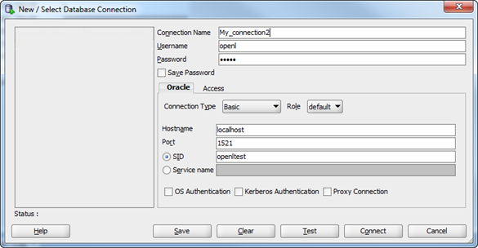
Figure 2: Creating a connection to the Oracle database
- Enter username and password values defined when installing the database.
- Start OpenL Tablets WebStudio and in the third step, select a multi-user mode and production application mode.
- Select the Oracle database type and define database URL, username, and password.
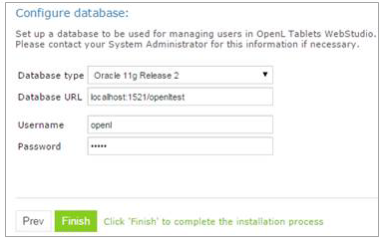
Figure 3: Creating a connection to the Oracle database in the installation wizard
- Click Finish.
- Log in as user a1 with password a1.
Note that even after configuring the database as user storage all default users are available for login. The user a1 with administrative rights can manage user settings in OpenL Tablets WebStudio, for example, create a user or add privileges to a user. All user management activities can be performed via OpenL Tablets WebStudio UI, in the Admin > User Management section.
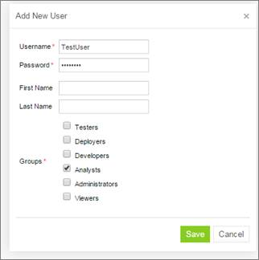
Figure 4: Managing users in the User Management section of OpenL Tablets WebStudio
Right after applying changes in OpenL Tablets WebStudio, the updates are applied to the database. A user can log in and work under a newly created account in OpenL Tablets WebStudio.
Note: During installation, several tables are created in the database. If the same tables exist in the database from the previous usage, a conflict occurs. To avoid this situation, the following tables must be removed:
- ACCESSCONTROLENTRY
- GROUP2GROUP
- OPENLUSER
- schema_version
- USER2GROUP
- USERGROUP
- HIBERNATE_SEQUENCE table that has SEQUENCE_OWNER=OPENL
The previous steps describes configuration in case user starts OpenL Tablets WebStudio for the first time. Otherwise, in the openl\user-workspace folder, do the following changes:
- In the system-settings folder, locate the db.properties configuration file and edit it as follows:
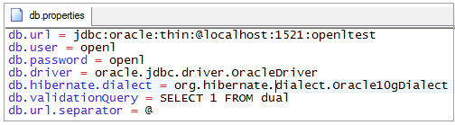
Figure 5: Configuration file with database settings
- In the system.properties file, set variable user.mode = multi.

Setting Up OpenL Tablets WebStudio with Installation Wizard
This topic describes the steps that must be taken after the first run of OpenL Tablets WebStudio under Tomcat or WebSphere Application Server. For more information, see Install OpenL Tablets WebStudio on WebSphere Application Server. Accept the default options provided by the wizard by clicking Next to move to the next step or change the options as required and click Next to proceed.
Proceed as follows:
- In the Welcome to OpenL Tablets WebStudio Installation Wizard window, click Start.
- In the next window, specify a working directory for OpenL Tablets.
By default, the following directory is displayed:
c:\Users\username\.openl\
This folder is referred to as <OPENL_HOME> in the documentation. It is highly recommended not to use the system drive for that.
- Click Next to proceed.
- Specify production and design repositories:
Connection types for setting up design and production repositories
Type | Description
Local | The repository is located on the local machine as a folder. This folder must be specified in the Repository Directory field.
Remote - RMI | The repository is located on a remote server and can be accessed by the RMI protocol. The Repository URL field displays URL for remote access to the repository.
Remote - WebDav | The repository is located on a remote server and can be accessed via WebDav protocol. The Repository URL field displays URL for remote access to the repository.
Database(JDBC) | The repository is located in a database installed either local or remote. Available only for  production repository. The Repository URL field displays URL for access to the database.
Database(JNDI) | The repository is located in a database installed either locally or remotely. This type is available only for production repository. The Repository URL field displays URL for accessing the database. Configuration settings are located in configuration files of the web server application.
The following table explains URL values according to the database type:
URL value according to the database type
Database | URL value
MySQL | jdbc:mysql://[host][:port]/[schema]
Oracle | jdbc:oracle:thin:@//[HOST][:PORT]/SERVICE
MS SQL | jdbc:sqlserver://[serverName[\instanceName][:portNumber]][;property=value[;property=value]]

Configuring OpenL Tablets WebStudio via JDBC Connection
When the OpenL Tablets WebStudio installation wizard appears, specify OpenL Tablets WebStudio working directory and then configure production repository settings in the Production Repositories window as follows:
- Select JDBC as the type of the connection database (JDBC).
- Provide URL and authentication data.
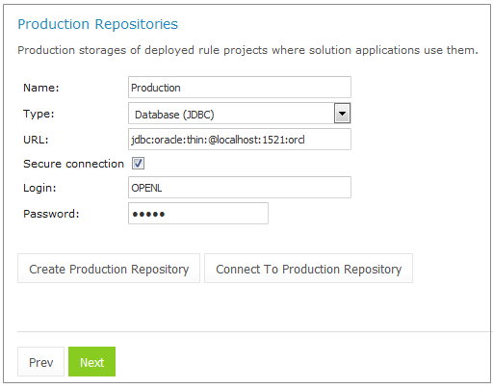
Figure 6: Setting up a JDBS connection using the installation wizard

Configuring OpenL Tablets WebStudio via JNDI Connection
To configure the OpenL Tablets WebStudio via JNDI connection, perform the following steps:
- Configuring Resources for JNDI Context
- Configuring Settings in WebStudio

Configuring Resources for JNDI Context
Resource settings must be configured before deploying the application. Proceed as follows:
- Open the \conf\context.xml file in Apache Tomcat and add the Resource tag as described in the following examples.
For the Oracle database, an example is as follows:
<Resource name=”jdbc/oracleJNDI” auth=”Container”
type=”javax.sql.DataSource” username=”user” password=”password”
driverClassName=”oracle.jdbc.OracleDriver”
url=”jdbc:oracle:thin:@localhost:1521:orcl”
maxActive=”8”
/>
For the MySQL database, an example is as follows:
<Resource name=”jdbc/mysqlJNDI” auth=”Container” type=”javax.sql.DataSource”
maxActive=”100” maxIdle=”30” maxWait=”10000”
username=”javauser” password=”javadude” driverClassName=”com.mysql.jdbc.Driver”
url=”jdbc:mysql://localhost:3306/javatest”
/>
For the MS SQL database, an example is as follows:
<Resource name=”jdbc/mssqlJNDI” auth=”Container”
type=”javax.sql.DataSource” username=”wally” password=”wally”
driverClassName=”com.microsoft.sqlserver.jdbc.SQLServerDriver”
url=”jdbc:sqlserver://localhost;DatabaseName=mytest;SelectMethod=cursor;”
maxActive=”8”
/>
- Save the context.xml file.

Configuring Settings in OpenL Tablets WebStudio
When the OpenL Tablets WebStudio installation wizard appears, specify OpenL Tablets WebStudio working directory and then configure production repository settings in the Production Repositories window as follows:
- Select JNDI as the type of the connection database.
- Enter a URL in the java:comp/env/<resource name> format.
Definition of the authentication data, that is, login and password, is not required in the installation wizard because this information is set in context.xml file already.
- Click Next.
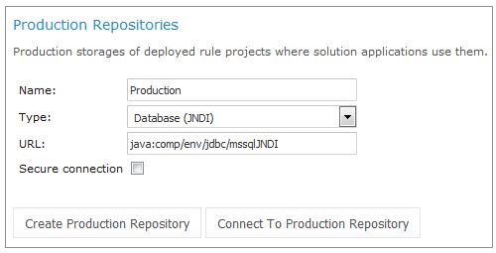
Figure 7: Setting up JNDI connection with installation wizard
For more information on repository security, see [OpenL Tablets WebStudio User Guide], the Repository Settings section.
- Select a user mode as described in the following table:
User modes
Mode | Description
Single-user | Only the user currently logged on to the computer can work with the OpenL Tablets WebStudio. For more information on the single user mode, see [OpenL Tablets WebStudio User Guide].
Multi-user (recommended) | Multiple users can run OpenL Tablets WebStudio with their unique names.
- For the Multi-user mode, in the Select application mode area, specify the database for users management:
User management databases
Database | Description
Demo | Default database which contains a predefined list of users and does not require additional setup.
Production | External MySQL database with a customizable list of users.
- If the Production mode is selected, in the Configure database area that appears, modify the database parameters as follows:
Database parameters
Parameter | Description
Database URL | By default, localhost:3306/openl
Username / Password | Username and password specified for the MySQL database user as defined in Configuring External User Database.
- Click Finish to complete setup.
As a result, for the Multi-user mode, the login screen appears for entering user’s credentials to start working with OpenL Tablets WebStudio. By default, there are the following users in OpenL Tablets WebStudio:
OpenL Tablets WebStudio users
User name | User password | Groups
user | user | Viewers
u0 | u0 | Testers
u1 | u1 | Developers, Analysts
u2 | u2 | Viewers
u3 | u3 | Viewers
u4 | u4 | Deployers
a1 | a1 | Administrators
For a list of users predefined in the demo application mode, see [OpenL Tablets WebStudio User Guide], User Management > Manage Users.

Configuring Settings for Microsoft Excel Application
The Open in Excel functionality does not work under the default settings if Apache Tomcat is installed on Windows using Windows Service Installer as described in Installing Apache Tomcat Using Windows Service Installer. This case requires a user to make several configuration changes.
To change DCOMConfig settings for Excel, proceed as follows:
- Run the dcomconfig.exe utility using administrator credentials:
Start > dcomcnfg.exe
The Component Services window appears.
- In Console Root, select Component Services > Computers > My Computer > DCOM Config.
- Navigate to the Microsoft Excel Application at the right.
If Microsoft Excel Application is not available under DCOMConfig settings, on 64 bit system with 32 bit Office, select Start > Run mmc -32 > File > Add/Remove Snap-in… > Component Services > Add > OK > Console Root > Component Services > Computers > My Computer > DCOM Config > Microsoft Excel Application.
- Right click Microsoft Excel Application and in the drop-down menu, select Properties.
- In the Microsoft Excel Application window, click the Identity tab.
- Select This user.
- Click OK to complete.
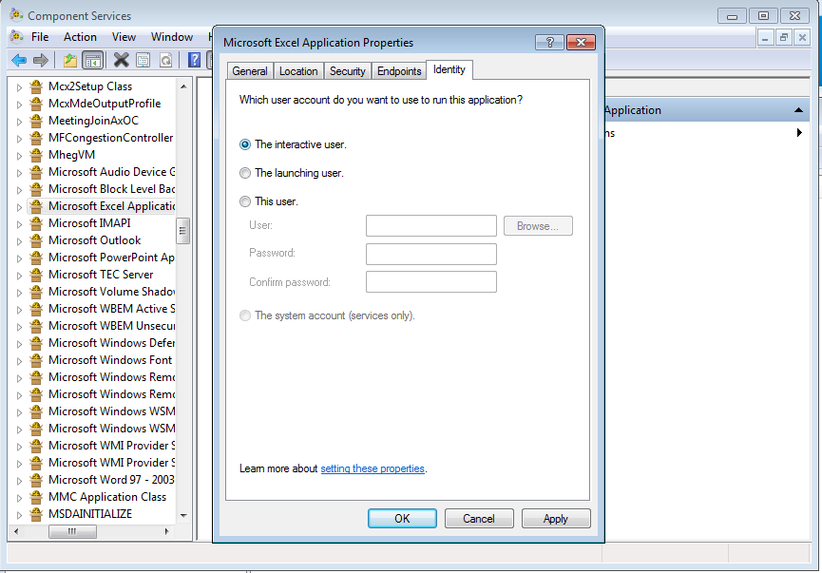
Figure 8: Microsoft Excel Application Properties

OpenL Tablets WebStudio Customization
This section describes additional configuration for OpenL Tablets WebStudio and includes the following topics:
- Updating User Database Configuration
- Configuring User Mode
- Configuring Google Analytics
- Configuring Private Key for Repository Security

Updating User Database Configuration
User database settings, such as connection, login, and password data, are modified using the <OPENL_HOME>/system-settings/db.properties file.
An example of the configuration that can be used for the user database is as follows:
db.hibernate.dialect = org.hibernate.dialect.MySQLDialect
db.driver = com.mysql.jdbc.Driver
db.url = jdbc:mysql://localhost:3306/openl
db.user = openl_user
db.password = openl_password

Configuring User Mode
Normally, user mode in OpenL Tablets WebStudio is set to multi-user by using OpenL Tablets WebStudio Installation Wizard as described in Setting Up OpenL Tablets WebStudio with Installation Wizard.
User mode can also be changed as a JVM option for Tomcat. For that, open the Apache Tomcat Properties dialog as described in Installing Apache Tomcat Using Windows Service Installer, and in the Java Options text box, add the following line:
-Duser.mode=multi
Note: User mode set as a Java option takes precedence over the corresponding value specified in the OpenL Tablets WebStudio Installation Wizard. So if both are defined, the Java option value is used.

Configuring Google Analytics
Google Analytics is a service offered by Google that generates detailed statistics about website traffic and traffic sources. To configure Google Analytics for OpenL, open the Apache Tomcat Properties dialog as described in Installing Apache Tomcat Using Windows Service Installer and in the Java Options text box, add the following lines:
-Dwebstudio.analytics=number
Alternatively, configure Google Analytics for OpenL in the config.properties file located in \WEB-INF\conf\ as follows:
webstudio.analytics=number
number is a number provided by Google during registration.

Configuring Private Key for Repository Security
OpenL Tablets WebStudio allows connecting to secured repositories. In this case, passwords are stored in OpenL Tablets WebStudio workspace. To improve passwords protection, a private key can be used.
Private key is a special secure sentence for coding and encoding repository passwords. By default, the private key is empty. It can be set up as a JVM option for Tomcat by adding and specifying the value of the following parameter:
repository.encode.decode.key.
The private key must be specified without spaces.
Note: The private key must be configured prior to creating any secured connections. Otherwise, all stored passwords become invalid.

Deploy OpenL Tablets Web Services under Apache Tomcat
This chapter is designed for rule developers who need to use business rules as separate web services.
For more information on how to configure OpenL Tablets Web Services, see [OpenL Tablets Web Services Usage and Customization Guide].
Before deploying OpenL Tablets Web Services under Apache Tomcat, ensure the following tasks are performed:
- The JAVA_HOME environment variable is set to the pathname of the directory where JDK is installed.
- JVM options are set up as described in Installing Apache Tomcat.
The folder where Tomcat is installed is referred to as <TOMCAT_HOME>.
This section contains the following topics:
- Downloading Preconfigured OpenL Tablets Web Services
- Configuring OpenL Tablets Web Services for a Local File System Data Source
- Configuring File System Data Source to Support Versioning of Deployments
- Configuring OpenL Tablets Web Services for a Database Data Source

Downloading Preconfigured OpenL Tablets Web Services
To download the preconfigured OpenL Tablets Web Services application in a WAR file, proceed as follows:
- Locate http://openl-tablets.org/downloads.
- Click the appropriate OpenL Tablets Web Services WAR link.
- Save the WAR file to the <TOMCAT_HOME>\webapps directory.

Configuring OpenL Tablets Web Services for a Local File System Data Source
Using a file system as a data source for user projects means that projects are stored in a local folder. This folder represents single deployment containing all projects. Each project must also be represented as a separate folder. This is the default data source configured in the system.
To deploy OpenL Tablets Web Services, configure a local file system as a data source as follows:
- Navigate to the <TOMCAT_HOME>\webapps folder and extract the OpenL Tablets Web Services WAR file.
For example, right click the OpenL Tablets Web Services WAR file name and select 7-zip > Open archive.
For more information on downloading OpenL Tablets Web Services as a WAR file, see Downloading Preconfigured OpenL Tablets Web Services.
- Navigate to the WEB-INF\classes folder, open the openl-ruleservice.properties file, and for the ruleservice.datasource.dir setting, define the address to the folder with projects.
For example:
ruleservice.datasource.dir = d:/datasource/
Note that for proper parsing of Java properties file, the path to the folder must be defined with a slash (‘/’) as the folders delimiter. Back slash “\” is not allowed.
- Check if the property is defined as ruleservice.datasource.type = local.
- Save the rule project in the appropriate datasource folder.
Every rule project must be represented as a separate folder. As an example, use OpenL Tablets Tutorial available at http://openl-tablets.org/documentation/tutorials.
- To run Tomcat, in <TOMCAT_HOME>\bin, click the startup.bat file.
To ensure the deployment is successful, try loading the appropriate CXF page with web services.
An example is http://localhost:8080/openl-tablets-ws-X.X.X.
Note: The Tomcat log file contains a URL that must be used to run the OpenL Tablets Web Services. For a file system data source, the URL must resemble http://localhost:8080/<ws war file name>/<datasource folder>/<rule project name>?wsdl, where <datasource folder>/<rule project name> can be taken from the Tomcat log file.
Users can also pack their rule projects in a jar file and use this file as a data source as described in [OpenL Tablets Web Services Usage and Customization Guide], JAR File Data Source section.

Configuring File System Data Source to Support Versioning of Deployments
To deploy several projects which use the same Java classes, in openl-ruleservice.properties, set the ruleservice.datasource.filesystem.supportDeployments property to true.
To enable saving different versions of the same project, in openl-ruleservice.properties, set the ruleservice.datasource.filesystem.supportVersion property to true.
Storing project versions becomes available only when ruleservice.datasource.filesystem.supportDeployments=true.
Each project must be located in a separate folder with name ending resembling _v2, or _v0.0.2 for old format of deployments.
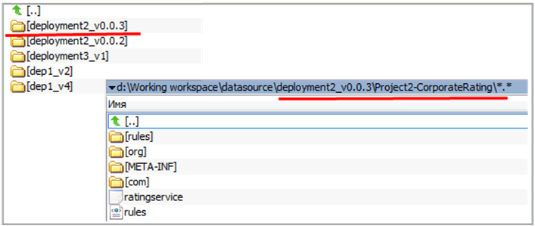
Figure 9: File system data source with versions

Configuring OpenL Tablets Web Services for a Database Data Source
This section describes how to configure settings to connect to a database for storing deployed projects there. Such configuration requires that the appropriate database exists and is launched. The following topics are included:
- Adding Drivers and Installing and Configuring the Database
- Configuring OpenL Tablets Web Services via JDBC Connection
- Configuring OpenL Tablets Web Services via JNDI Connection

Adding Drivers and Installing and Configuring the Database
Before configuration, perform the following steps:
- Add the appropriate driver library for a database in OpenL Tablets Web Services, to \WEB-INF\lib\.
Alternatively, locate required libraries directly in \<TOMCAT_HOME>\lib with other Tomcat libraries.
Driver name for appropriate databases
Database | Driver
MySQL | mysql-connector-java-5.1.31.jar
Oracle | ojdbc6.jar
MS SQL | hsqldb-2.3.2.jar
All libraries are already located in the OpenL Tablets WebStudio war file \WEB-INF\lib\.
For more information on URL value according to the database type, see the URL value according to the database type table in Setting Up OpenL Tablets WebStudio with Installation Wizard.
- Install the database, defining login and password and creating a new schema or service.
Ensure all database settings are completed. For more information on supported databases and versions, see http://openl-tablets.org/.

Configuring OpenL Tablets Web Services via JDBC Connection
To set up JDBC connection settings for OpenL Tablets Web Services, proceed as follows:
- Open WEB-INF\classes\openl-ruleservice.properties file and set ruleservice.datasource.type = jcr.
- Open the \WEB-INF\classes\rules-production.properties file.
Comment the folloiwng settings:
#production-repository.factory = org.openl.rules.repository.factories.RmiJackrabbitRepositoryFactory
#production-repository.uri = //localhost:1099/deployment-repository
- Remove the comment mark from the following lines:
production-repository.factory = org.openl.rules.repository.factories.JdbcDBRepositoryFactory
production-repository.uri = jdbc:mysql://localhost/deployment-repository
- Set the URL value for production-repository.uri according to the appropriate database as described in the URL value according to the database type table in Setting Up OpenL Tablets WebStudio with Installation Wizard.
- Set the login production-repository.login and password production-repository.password for connection to the database defined while installing the database.
The password must be encoded via the Base64 encoding schema when repository.encode.decode.key is also defined.

Configuring OpenL Tablets Web Services via JNDI Connection
This section describes how to configure JNDI connection when OpenL Tablets Web Services is started under Apache Tomcat. Before configuration, ensure that resources are set up in the context.xml file as described in Configuring Resources for JNDI Context.
To configure OpenL Tablets Web Services via JNDI connection, proceed as follows:
- Open WEB-INF\classes\openl-ruleservice.properties file and set ruleservice.datasource.type = jcr.
- Open the \WEB-INF\classes\rules-production.properties file and comment the following settings:
#production-repository.factory = org.openl.rules.repository.factories.RmiJackrabbitRepositoryFactory
#production-repository.uri = //localhost:1099/deployment-repository
- Remove the comment mark from the following lines:
production-repository.factory = org.openl.rules.repository.factories.JndiDBRepositoryFactory
production-repository.uri = java:comp/env/jdbc/deploymentDB
- Change the URL value for production-repository.uri according to the appropriate database as described in the URL value according to the database type table in Setting Up OpenL Tablets WebStudio with Installation Wizard.
Note: Login and password are not required for definition inside the rules-production.properties file while configuring JNDI settings.
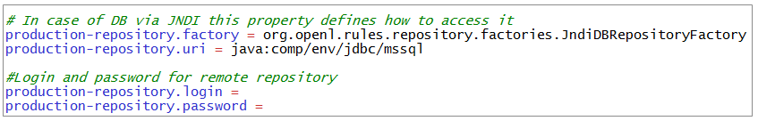
Figure 10: OpenL Tablets Web Services configuration file for JNDI settings

Install OpenL Tablets WebStudio and OpenL Tablets Web Services on WebSphere Application Server
This section explains how to install OpenL Tablets WebStudio and OpenL Tablets Web Services on WebSphere Application Server. The following topics are included:
- Prerequisites
- Setting Up JVM Options for WebSphere Application Server
- Preparing OpenL Tablets WAR Files
- Deploying OpenL Tablets Web Applications on WebSphere Application Server
- Configuring Settings for JDBC Connection
- Configuring Settings for JNDI Connection
- Configuring Settings for Microsoft Excel Application

Prerequisites
Before deploying OpenL Tablets WebStudio on WebSphere Application Server, IBM WebSphere Application Server v. 8.5 or later must be installed on the user’s local machine, or users must be granted access to a WebSphere Application Server instance with logon that has appropriate permissions to configure JVM options.
For more information on how to install IBM WebSphere Application Server, see Oracle online documentation, section Installing and Configuring WebSphere 8.5 at http://docs.oracle.com/cd/E24902_01/doc.91/e23435/inst_config_was85_win.htm
IMPORTANT! When defining the Shared Resource Directory during the installation process, the path to the directory must be specified without spaces. Otherwise, OpenL Tablets WebStudio fails.

Setting Up JVM Options for WebSphere Application Server
To set up JVM options for WebSphere Application Server, proceed as follows:
- In WebSphere Application Server Console, navigate to Servers/ServerTypes/WebSphere Application Servers.
The server appears in the right pane.
- In the right pane, click the server name.
The default value is server1.
- Locate the Server Infrastructure area and expand the Java Process Management node.
- Click Process Definition.
- In the upper right part of the window, click the Java Virtual Machine link.
- In the Initial heap size text box, enter 256.
- In the Maximum heap size text box, enter 1024.
- In the Generic JVM Arguments, add the following line:
-XX:+UseParallelOldGC -XX:PermSize=128m -XX:MaxPermSize=384M -Dclient.encoding.override=UTF-8
- Click OK.
- In the Message window which appears in the top of the form, click Save directly to the master configuration to save changes.
- Restart WebSphere Application Server.

Preparing OpenL Tablets WAR Files
This section describes how to configure OpenL Tablets WebStudio and Web Services WAR files. Proceed as follows:
- Locate http://openl-tablets.org/downloads.
- Click the appropriate OpenL Tablets WAR link.
- Save the file in a temporary folder.
- Open the downloaded WAR file as a ZIP archive.
- In the \WEB-INF\lib\ folder, remove the following JAR files:
jboss-transaction-api_1.1_spec-1.0.0.Final.jarjboss-transaction-api_1.2_spec-1.0.0.Final.jarjta-1.1.jar
- Save the WAR file.

Deploying OpenL Tablets Web Applications on WebSphere Application Server
This section describes how to deploy OpenL Tablets WebStudio and OpenL Tablets Web Services on WebSphere Application Server and includes the following topics:
- Deploying OpenL Tablets WebStudio on WebSphere Application Server
- Deploying OpenL Tablets Web Services on WebSphere Application Server

Deploying OpenL Tablets WebStudio on WebSphere Application Server
To deploy OpenL Tablets WebStudio on WebSphere Application Server, proceed as follows:
- In a browser, enter the following URL:
https://localhost:9043/ibm/console
This is a default port for local installation. The WebSphere Application Server Console window appears.
- Navigate to Applications / Application Types / WebSphere enterprise applications.
- In the top line tool bar, click the Install button.
- In the Path to the new application area, select the modified OpenL Tablets WebStudio WAR file.
The Local file system option is selected by default.
- Click Next.
- In the Step 2: Map modules to servers page, select the check box on the left to the file name and click Next.
- In the Step 3: Map virtual hosts for Web modules page, select the check box on the left to the file name and click Next.
- In the Step 4: Map context roots for Web modules page, in the Context Root text field, enter /webstudio and click Next.
- Click Finish to complete.
- When the installation process is complete, click the Manage Applications link.
- In the next window, in the list of applications, click the OpenL Tablets WebStudio WAR file link.
- In the next window, locate the Default Properties area and click the Class loading and update detection link.
- In the next window, select the following radio buttons:
- Classes loaded with local class loader first (parent last)
- Single class loader for application
- Click OK to finish.
- In the next window, click the Save directly to the master configuration link.
Now the OpenL Tablets WebStudio application is installed and started. If not, start the application.
- Run OpenL Tablets WebStudio by entering http://localhost:9080/webstudio/ in a browser.
The Welcome to OpenL Tablets WebStudio Installation Wizard window appears allowing to set up the application as needed. For more information on the application setup, see Configuring External User Database, Setting Up OpenL Tablets WebStudio with Installation Wizard and OpenL Tablets WebStudio Customization.

Deploying OpenL Tablets Web Services on WebSphere Application Server
To deploy OpenL Tablets Web Services on WebSphere Application Server, complete steps 1-16 described in Deploying OpenL Tablets WebStudio on WebSphere Application Server.
For more information on configuring the OpenL Tablets Web Services settings, see Deploy OpenL Tablets Web Services under Apache Tomcat.

Configuring Settings for JDBC Connection
To configure OpenL Tablets WebStudio or OpenL Tablets Web Services, prepare war files as described in Preparing OpenL Tablets WAR Files and then do one of the following:
- Configuring OpenL Tablets WebStudio via JDBC Connection
- Configuring OpenL Tablets Web Services via JDBC Connection

Configuring Settings for JNDI Connection
This section describes configuring JNDI connection settings and includes the following topics:
- Configuring Global JNDI Context
- Configuring Local JNDI Context

Configuring Global JNDI Context
To configure global JNDI settings, proceed as follows:
- To configure authentication data, proceed as follows:
- Open the https://localhost:9043/ibm/console login page.
- Select Security – Global > Authentication > Java Authentication and Authorization Service.
- Click J2C authentication data .
- In the window that appears, click New, fill in all mandatory fields, and click Ok and Save.
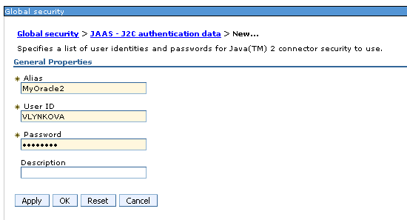
Figure 11: Setting up global security in WebSphere
- To define a JDBC provider, proceed as follows:
- In the Resources section on the left panel, click JDBC providers and select the appropriate scope of the current user and server.
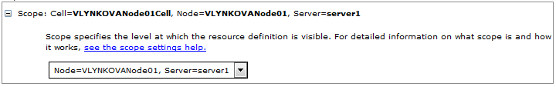
Figure 12: Configuring scope for new JDBC provider
- Click New to create a provider.
- Select the required Database type, for example, Oracle, Provider type, for example, Oracle JDBC Driver, Implementation type, for example, Connection pool data source, enter the name, and click Next.
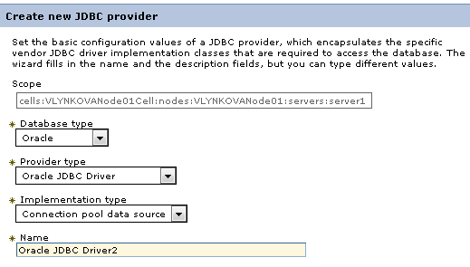
Figure 13: Creating a new JDBC provider
- In the next page, fill in the location to appropriate driver for the Oracle database as described in the following example excluding the name of library itself:
Figure 14: Defining the location of appropriate database lib
- Click Ok and Finish on the last installation page.
- Click Save to complete and save provider.
- To create a data source, proceed as follows:
- In Data source section, select the appropriate scope of the current user and server.
- Click New.
- Provide basic data source information, such as data source name and JNDI name.
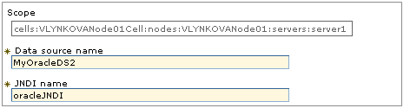
Figure 15: Configuring a new Data Source
- Click Next.
- Select a JDBC provider and click Next.
- Define URL of the appropriate data user to connect to.
An example is jdbc:oracle:thin:@localhost:1521:orcl.
- Ensure that the Use this data source in container managed persistence (CMP) option is cleared and click Next.
- Define authentication settings.
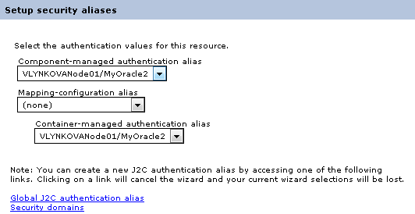
Figure 16: Configuring Data Source
- Click Next and Finish and then save the created configuration.
When the JNDI connection is created and saved, a user can connect to the database where production repository will be stored. The database URL, that is, JNDI name, must have a short version of it without prefixes java:comp/env/jdbc/ because it is configured as a global JNDI context.
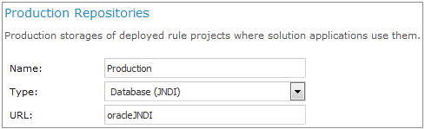
Figure 17: Connecting to the database in OpenL Tablets WebStudio via global JNDI context
- To start OpenL Tablets WebStudio on WebSphere, proceed as described in Deploying OpenL Tablets WebStudio on WebSphere Application Server.
- To start OpenL Tablets Web Services on WebSphere, proceed as described in Deploying OpenL Tablets Web Services on WebSphere Application Server.
Figure 18: Configuration settings for OpenL Tablets Web Services via global JNDI context

Configuring Local JNDI Context
Typically Enterprise JavaBeans (EJB) does not use the global name to look up the data source while configuring JNDI connection in an enterprise application, such as WebSphere. Instead, EJB uses a logical JNDI name that is mapped to the global JNDI name of the data source. Proceed as follows:
- To map a logical JNDI name to the global JNDI data source name, declare a resource reference in the deployed application \WEB-INF\web.xml file as follows:
<resource-ref>
<description>Resource reference to a factory for java.sql </description>
<res-ref-name>jdbc/JNDIName</res-ref-name>
<res-type>javax.sql.DataSource</res-type>
<res-auth>Container</res-auth>
</resource-ref>
The value of the <res-ref-name> tag is a logical JNDI name EJB uses to look up the data source. The value of the <jndi-name> tag is a global name of the data source to which the logical name is mapped.
- When the resource reference settings are added, save the file and repack the application.
- Start deploying OpenL Tablets WebStudio or OpenL Tablets Web Services as described in Deploying OpenL Tablets WebStudio on WebSphere Application Server, steps 1-5.
- In the Map resource references to resources window, in the Set Multiple NDI Names list, select Target Resource JNDI Name and click Next.
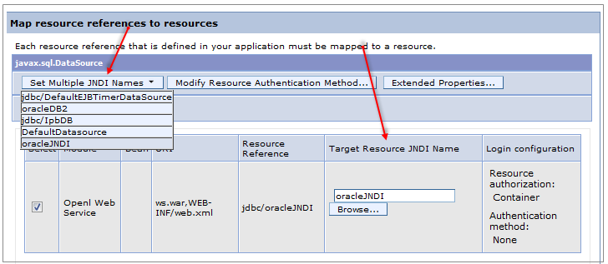
Figure 19: Configuring mapping for a local JNDI context
- Complete configuration as described in Deploying OpenL Tablets WebStudio on WebSphere Application Server, steps 7-16.

Configuring Settings for Microsoft Excel Application
The Open in Excel functionality does not work if WebSphere Application Server 8.5 is used under default settings. Execute configuration changes described in Configuring Settings for Microsoft Excel Application.

OpenL Tablets WebStudio and Web Services Integration
This section describes how to set up OpenL Tablets WebStudio and OpenL Tablets Web Services integration and enable backward compatibility and includes the following topics:
- Deploying Rules to the Production Server
- Integrating OpenL Tablets WebStudio and OpenL Tablets Web Services via Jackrabbit Repository
- Integrating OpenL Tablets WebStudio and OpenL Tablets Web Services via Database Repository
- Enabling Backward Compatibility of OpenL Tablets WebStudio with Previous Versions of OpenL Tablets Web Services

Deploying Rules to the Production Server
After integration any changes can be made in user’s rule in OpenL Tablets WebStudio, and then the project must be saved and redeployed. These changes immediately affect the rule represented as web service. During development, rules are stored in the file system of the development server. When development is finished, rules can be deployed to the production server as follows:
- OpenL Tablets WebStudio sends the rules project to one of the following locations depending on the integration type:
- Repository Engine, that is, Jackrabbit web application, using the RMI or WebDAV protocol,
in case of integration via Jackrabbit repository.
- database repository, using the JDBC driver for connection, in case integration via database repository.
- The rules are saved on the production server.
- OpenL Tablets Web Services detects a new version of the deployed rules and starts using it.
The following diagram illustrates the OpenL Tablets WebStudio and OpenL Tablets Web Services integration:
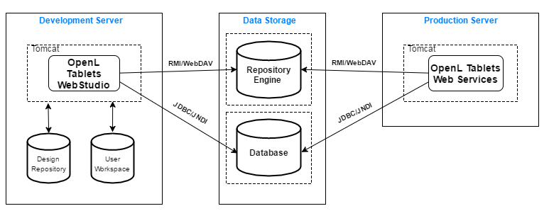
Figure 20: OpenL Tablets WebStudio and OpenL Tablets Web Services deployment

Integrating OpenL Tablets WebStudio and OpenL Tablets Web Services via Jackrabbit Repository
This section describes how to set up an RMI-integrated environment that enables work with business rules from OpenL Tablets WebStudio and launch these rules as OpenL Tablets Web Services.
In the following example, OpenL Tablets WebStudio must be run under Tomcat.
All sources related to JCR repository can be downloaded at http://openl-tablets.org/downloads, the Repository (ZIP file) link. The repository package is a ZIP file containing repository server, configuration files, and an empty JCR repository.
Proceed as follows:
- Copy the openl-tablets-remote-repository-server-X.X.X.war file from the repository package into \<TOMCAT_HOME>\webapps.
- Copy the deployment-repository folder into the <OPENL_HOME> folder.
By default, the repository folder name is deployment-repository. Settings described further use this name.
- In \<openl-tablets-remote-repository-server-X.X.X.war>\jackrabbit\bootstrap.properties, set up repository settings as follows:
repository.home=<OPENL_HOME>/deployment-repository
repository.name=deployment-repository
# RMI Settings
rmi.enabled=true
rmi.port=1099
rmi.host=0.0.0.0
- For Tomcat version 8.10-8.23, open the \<openl-tablets-remote-repository-server-X.X.X.war>\WEB-INF\web.xml file and in the Repository Startup Servlet and Repository Servlet sections, inside the <init-param> tag, modify <param-value> and <param-value> as follows:
<init-param>
<param-name>bootstrap-config</param-name>
<param-value>/jackrabbit/bootstrap.properties</param-value>
…..
- In the \<openl-tablets-remote-repository-server-X.X.X.war>\jackrabbit\bootstrap.properties file, update the repository.config property as follows:
repository.config=/jackrabbit/jackrabbit-repository.xml
- Set up OpenL Tablets Web Services as follows:
- Open the \<TOMCAT_HOME>\webapps\<ws project name>\WEB-INF\classes\openl-ruleservice.properties file and set ruleservice.datasource.type = jcr.
- In the WEB-INF\classes\rules-production.properties file, ensure production-repository.uri is correct.
- To run OpenL Tablets WebStudio, in a browser, enter http://localhost:8080/<webstudio war file name>.
- Set up the appropriate design and production repositories settings in OpenL Tablets WebStudio administration.
In this example, production repository settings must be as follows:
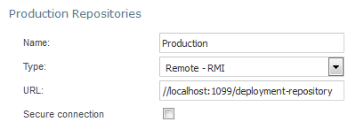
Figure 21: Production repository settings for RMI connection

Integrating OpenL Tablets WebStudio and OpenL Tablets Web Services via Database Repository
This section describes an alternative way of how to set up an integrated environment that enables work with business rules from OpenL Tablets WebStudio and launch these rules as OpenL Tablets Web Services. To set up OpenL Tablets WebStudio and OpenL Tablets Web Services integration using the database as storage for production repository, proceed as follows:
- Install OpenL Tablets WebStudio and OpenL Tablets Web Services on the same application serverю
- Connect OpenL Tablets WebStudio to the database to store deployed projects as described in Setting Up OpenL Tablets WebStudio with Installation Wizard.
- Configure OpenL Tablets Web Services for a database data source as described in Configuring OpenL Tablets Web Services for a Database Data Source.

Enabling Backward Compatibility of OpenL Tablets WebStudio with Previous Versions of OpenL Tablets Web Services
To configure the compatibility of OpenL Tablets WebStudio deployment configuration with the previous versions of OpenL Tablets Web Services, such as version 5.9.3 and earlier, switch the deployment.format.old parameter in the system.properties file to true. If the parameter does not exist, it must be created.

Troubleshooting Notes
If OpenL Tablets WebStudio is deployed under Tomcat in the Unix/Linux environment, consider the following troubleshooting recommendations:
- Before starting Tomcat under Linux, make sure that no Java processes are running:
sudo ps -A | grep j
If found, the process name and number are displayed.
- If any Java process is running, stop it as follows:
kill -9 <process number>
- Make sure that port 8080 is available as follows:
sudo netstart –an | grep 8080
- Run Tomcat under Linux as follows:
<TOMCAT_HOME>/bin/startup.sh
- If the command not found error appears, mark the .sh file as an executable script as follows:
chmod +x startup.sh
- If the Permission denied or The BASEDIR environment variable is not defined correctly error is displayed, make all .sh files in the bin folder executable as follows:
chmod 777 *.sh
- Verify that all .sh files in the bin folder are executable as follows:
ls –la
- Run Tomcat as follows:
<TOMCAT_HOME>/bin/startup.sh

Frequently Asked Questions
This section provides the most common questions and answers related to the OpenL Tablets installation procedure. For more information on working with Java, Tomcat, and other third party software, see the corresponding sites of the software manufacturers.
Frequently Asked Questions
# | Question | Answer
1 | How can I check if Java is installed on my PC? | Proceed as follows:  - Open Start > Control Panel.  - Perform either of the following:  - For Windows XP, double click Add or Remove Programs.  - For Windows 7/Vista, click Programs > Programs and Features.  - Look through the list for Java(TM)… or Java(TM) Update… items. If any is present, Java is installed on your PC.
2 | During Java installation, the page for Java registration appears. Do I have to register Java? | No, it is optional. You can close the registration page.
3 | How can I check which version of Java is installed on my PC? | Open the Verify Java Version page and click the Verify Java Version button.  In a few seconds a new page appears where you will find the message similar to the following one: Your Java version: Version 6 Update 26.
4 | How can I see the error message in the Tomcat console that appears when I start Tomcat? The error screen disappears too quickly. | Proceed as follows:  - Click Start > Run.  - Locate the <TOMCAT_HOME>\bin folder.  - Select catalina.bat and enter run in the command line.

